Day 4 - Introduction to Scripting

Task 1:

Create a shell script to print the HTTP error code of guvi.in & print, the success/failure message based on the error code response.

Script :

#! /bin/bash

url="https://guvi.in"

status_code=$(curl -o /dev/null -s -w "%{http_code}\n" $url)

if [ "$status_code" -eq 200 ]; then

echo "The $url is reachable"

elif [ "$status_code" -eq 400 ]; then

echo "page not found"

else

echo "the response of the URL is $status_code"

fi

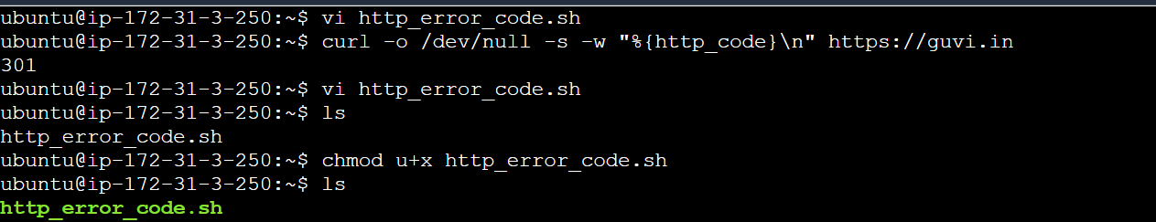

O/P

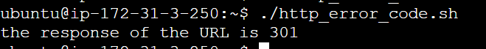

Tried with google.com its reachable

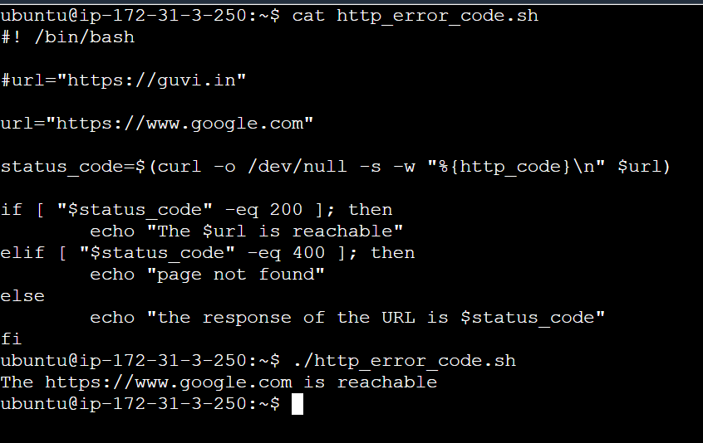

Task 2 :

Given a file, replace all occurrence of the word ""give"" with ""learning"" from the 5th line till the end in only those lines that contain the word "welcome"

1. Replace give with learning

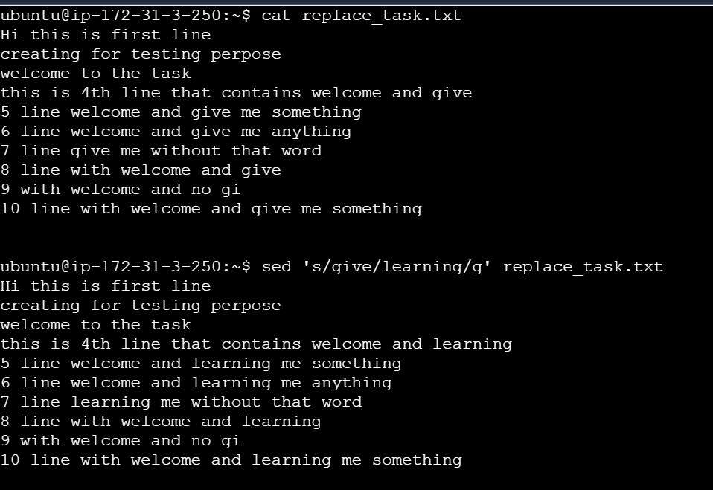

1. Replace in a file give to learning from 5th line

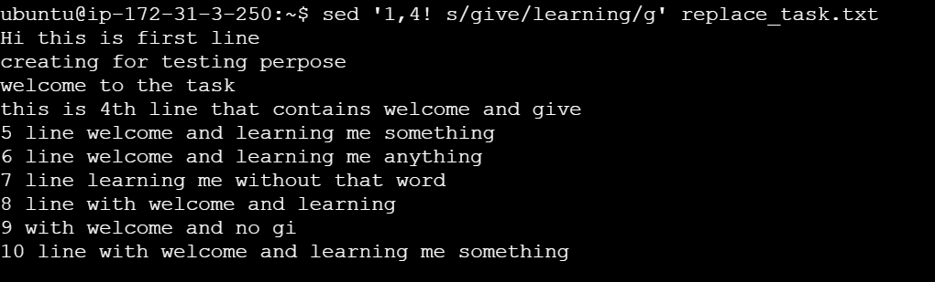

In above screenshot 4th line have give but it didn’t replace with learning. From 5th line only it got replaced with learning . From 5th line only replace the give with learning

1. Replace give with learning if the word has welcome from 5th line to end of the line

Command : sed -e '5,$ { /welcome/ s/give/learning/g }' replace_task.txt

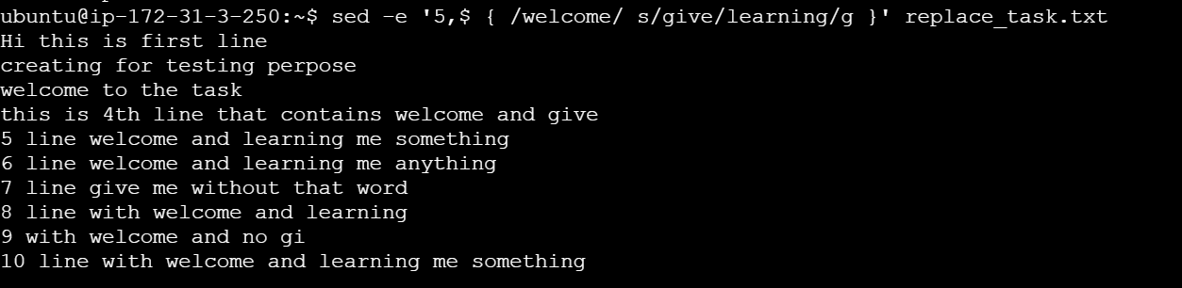

Above screenshot is **the final output** of task 2